CONTACT LENS CARE & INSTRUCTION

Adapting to your new lenses: Begin with 5-6 hours on the first day, then increase 1-2 hours per day until a daily maximum of 16 hours per day.

Remove your lenses immediately: if you are experiencing any of the following symptoms:
1. Discomfort, pain, or increased light sensitivity
2. Blurry, cloudy, hazy, or foggy vision
3. Redness of the eye
4. Infection, mucus discharge, or swelling
These are symptoms of infection, any contact lens wear during an active eye infection will make the infection spread deeper into the eye tissue and could lead to permanent loss of vision. In the event of an infection, please contact us for an evaluation and treatment office visit.

Overnight Wear: Any overnight wear of contact lenses gives a 7x greater risk of serious eye disease. It is always the healthiest choice to remove your contact lenses nightly. During your eye exam, please discuss your situation regarding overnight wear with your eye doctor. This will ensure that you are in an appropriate lens design for your specific needs.

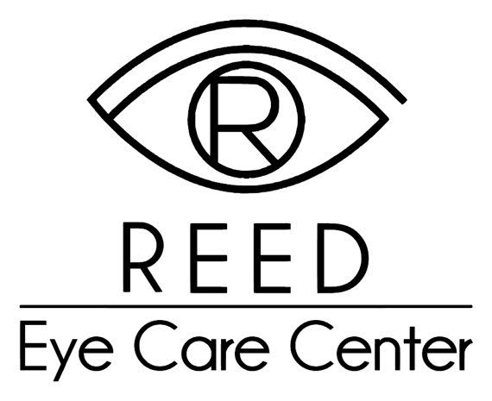
Caring for your Contact Lenses: Do not use tap water. All contact lens solutions are not designed to be used the same way. Always read and follow the directions as labeled on your contact lens solution. The available generic solutions as not as gentle to the eye, will not clean nor hydrate your contacts as well as the solution recommended by your doctor. Don't forget to replace your storage case monthly.

Disposable Schedule: Exceeding the recommended discard schedule, puts your eyes at greater risk of contact lens related eye disease. Your lenses are designed to be discarded within the time period instructed by the doctor.

Prescription Glasses: As a contact lens wearer you should always maintain and update your prescription eyeglasses. Contact lenses are not meant to be your only means of vision correction.

Non-Prescription Sunglasses: For added protection and comfort, it is recommended that you wear a good pair of polarized sunglasses with 100% UV protection. Sunglasses will also block the wind from potentially drying out your contact lenses.

Annual Eye Exams: Contact lenses are a medical device requiring at minimum an annual examination. Your contact lens prescription will expire in 1 year.

I have been instructed in the proper method of insertion, removal, use, and care of my contact lenses. I understand that follow-up care is extremely important and that it is my responsibility to keep my follow-up appointments. I have all questions answered to my satisfaction and have been instructed to contact this office with any further questions.

